Attachment:

Case Template
Name of Entity
Organizational Introduction | [Please include a brief introduction of no more than 200 words, about the company/institution, highlighting relevant background, achievements, and expertise in the field of biodiversity conservation and energy transition]
Address
Contact | Name |  | Position
Contact | Tel. |  | E-mail
Case Name | [Please provide a clear and concise name for the case]

Content Requirements: The case content should comprise two parts: the abstract and the main body. You are encouraged to include charts and data to enhance your presentation. The total word count should be approximately 1,000 words. Images should be between 3MB-5MB in size, with a resolution of at least 300 dpi.

Case Example:
Bird Nest on Power Lines: Promoting Ecological Harmony of the Sanjiangyuan

Abstract: The "Bird Nest on Power Lines" project was initiated by the State Grid Public Welfare Foundation in collaboration with State Grid Sichuan Electric Power Company, State Grid East Inner Mongolia Electric Power Company Limited, State Grid Gansu Electric Power Co., Ltd., State Grid Qinghai Electric Power Company, State Grid Xinjiang Electric Power Co., Ltd., and State Grid Xizang Electric Power Company Limited, alongside relevant governmental departments, social organizations, and eco-environmental research institutions. By thoroughly studying the habits of rare birds of prey, such as golden eagles, falcons, and upland buzzards near transmission lines in plateau and grassland areas, the project team crafted artificial bird nests from bamboo baskets and rattans. These nests were installed along power transmission lines in areas with high bird populations. The installations have successfully attracted birds to build 2,500 nests and hatch more than 1,600 fledglings. This initiative has contributed to carbon emission reduction and provided ecological service functions valued at RMB 123.53 million, effectively protecting the ecological environment of the Sanjiangyuan region.

PART 01 Case Background
Located in the hinterland of the Qinghai-Tibet Plateau, the Sanjiangyuan National Nature Reserve is the largest natural reserve in China and one of the world's most biodiverse high-altitude regions. Known as "China's Water Tower," it is home to large birds such as crows, hawks, falcons, and golden eagles.
From 2011 to 2016, a large power grid was gradually extended into the Sanjiangyuan National Nature Reserve in Qinghai, with projects like the Qinghai-Tibet Power Grid Interconnection and Yushu Power Grid Interconnection coming into operation. Power transmission towers, as the tallest structures in the region, became preferred perching and nesting sites for local birds. However, some birds were injured or killed due to high-voltage electric shocks and other factors. Bird activities also posed operational risks to the power grid, including wire corrosion and grid tripping, which threatened the stability and safety of power grid operations in the Tibetan area.
PART 02 Implementation
Initially, operation and maintenance personnel of the power transmission lines implemented several bird prevention and repelling measures on the transmission towers, such as installing bird spikes, bird repellent mirrors, and inclined bars to prevent birds from perching. However, these measures were ineffective, harming the birds and disrupting the stability of the biological chain in the Sanjiangyuan region, further damaging the fragile ecosystem of the plateau.
After studying and analyzing the habits of birds in the Sanjiangyuan region, State Grid Qinghai Electric Power Company set up artificial bird nests and falcon attraction structures on the transmission towers. This innovative approach shifted from traditional bird prevention and repelling to actively attracting birds and building "bird nests on power lines." This new strategy provided birds with more options for normal activities and perching, preventing them from settling on the overhead conductors of transmission lines and protecting them from high-voltage shocks.
Additionally, the company introduced high-tech bird monitoring equipment and conducted monthly statistics and registration of bird activities along power transmission lines at various altitudes and across different geographic and climatic regions in Qinghai Province. They also established a triennial archive, recording details of bird activities, nesting, reproduction, and migration patterns, and assigned a "house number" for each artificial bird nest for monitoring and management.
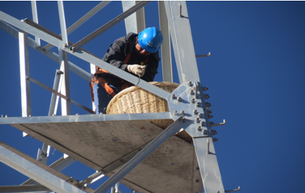 | 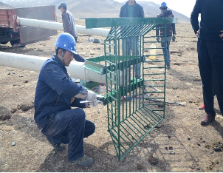
A worker is installing an artificial bird nest on a transmission tower. | Workers are installing falcon attraction structures

PART 03 Main Achievements
As of March 2020, a total of 168 artificial bird nests, 20 nest brackets, and 46 perches had been installed along the ±400kV Chaila Line (Qinghai Section) of the Qinghai-Tibet Power Grid Interconnection Project. These facilities successfully attracted birds to build 56 nests and hatch 138 fledglings. Additionally, on the 10kV and 35kV power transmission towers with frequent bird activities in Yushu Tibetan Autonomous Prefecture and Golog Tibetan Autonomous Prefecture, Qinghai Province, a total of 3,280 artificial bird nests and 16 falconry attraction structures had been installed. During operation and maintenance, it was found that 570 of these bird nests had been utilized by birds to build 242 nests and hatch 436 fledglings.
These efforts have not only effectively protect birds in the Sanjiangyuan National Nature Reserve but also reduced the number of power grid trips caused by birds by 98% year on year. Moreover, these measures have significantly lowered the operation and maintenance costs of the transmission lines while enhancing their overall value and contribution to economic and social development.
PART 04 Highlights and Innovations
(1) Collaborative Promotion: The "Bird Nest on Power Lines" project is jointly promoted by enterprises in collaboration with local governments, social organizations, and scientific research groups.
(2) Tailored Eco-Friendly Measures: Bird nests are designed according to the bodily forms and habits of the birds. Unique, eco-friendly prevention measures and technical standards are formulated for birds across different altitudes and voltage environments. Artificial bird nests and falcon attraction structures are set accordingly to accommodate these variations.
(3) Broad Promotion and Adaptation: Combining practical experiences and field survey and assessments, the project has been expanded to other plateau and grassland areas in Inner Mongolia, Sichuan, Gansu, Ningxia, Qinghai, Xinjiang, and Tibet.

